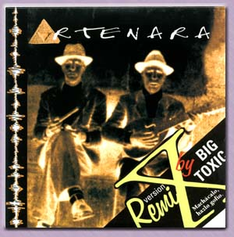
ARTENARA REMIX BY BIG TOXIC, 1998

TEMA | TIEMPO | AUDIO |  |  | VIDEO
CANTO DE LA MORENA V.O. |  |  | 5'01" | MP3
ARTENARA V. Timple Enrique Mateu |  |  | 5'46" | MP3
CANTO DE LA MORENA COOL MIX |  |  | 5'51" | MP3
ARTENARA COOL MIX |  |  | 6'42" | MP3
CANTO DE LA MORENA HIGH FLY |  |  | 5'33" | MP3 |  | QT
ARTENARA HIGH FLY |  |  | 6'53" | MP3

