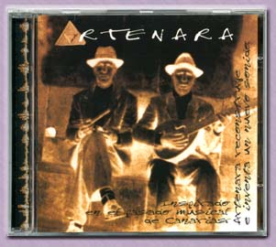
 |  |  | ARTENARA, 1998
 |  | TEMA |  |  |  |  |  |  | TIEMPO | AUDIO |  |  | VIDEO
 |  | ARTENARA |  |  |  |  |  |  |  |  | 5'38" | MP3 |  | QT
 |  | ARRORRO DEL MAR |  |  |  |  |  |  |  |  | 4'25" | MP3
 |  | CANTO DE LA MORENA |  |  |  |  |  |  |  |  | 4'56" | MP3 |  | QT
 |  | OLOR A CAMPO |  |  |  |  |  |  |  |  | 3'39" | MP3
 |  | PERINQUE |  |  |  |  |  |  |  |  | 3'59" | MP3
 |  | QUERIDA LOLA |  |  |  |  |  |  |  |  | 5'07" | MP3
 |  | GAROE |  |  |  |  |  |  |  |  | 5'11" | MP3
 |  | EL RINCON DEL VALIENTE |  |  |  |  |  |  |  |  | 4'26" | MP3
 |  | A MI MUJER NO LE GUSTA |  |  |  |  |  |  |  |  | 5'52" | MP3
 |  | AJEY |  |  |  |  |  |  |  |  | 4,08" | MP3
 |  | SOLO DE CUNA |  |  |  |  |  |  |  |  | 7'20" | MP3

